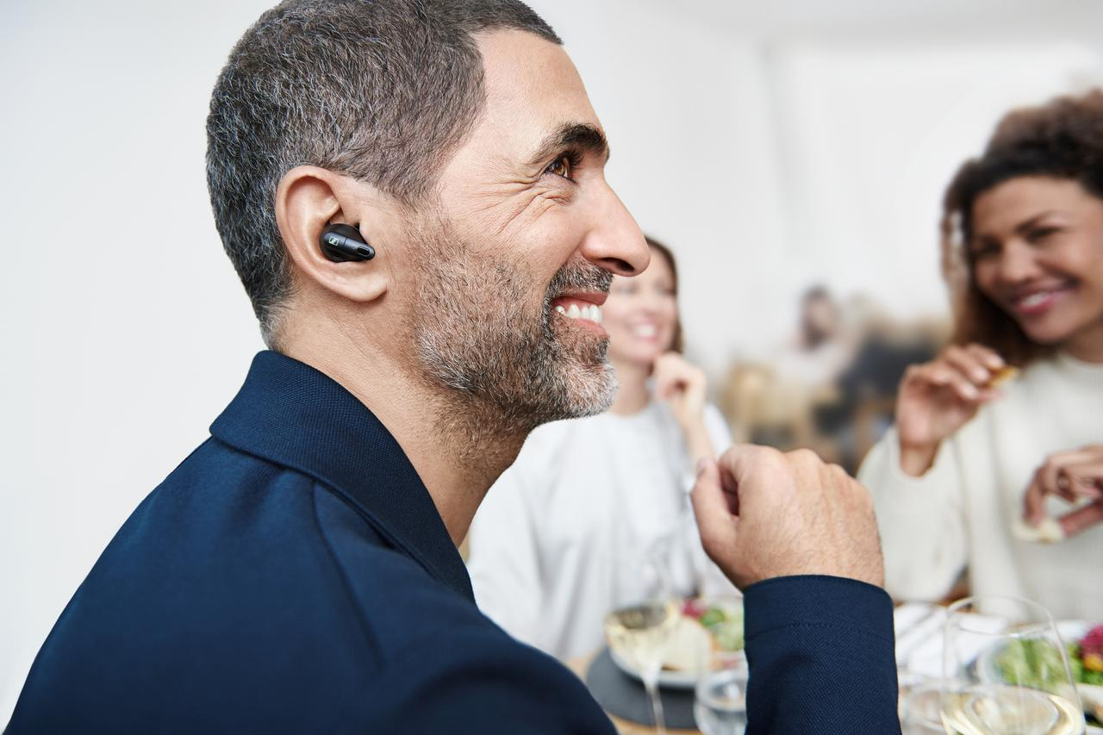
EFFORTLESSLY CLEAR COMMUNICATION WITH MODERN STYLE
The new Sennheiser Conversation Clear Plus – the perfect choice for crisper conversations in noisy environments whenever you need it.
Marlow, UK, January 5, 2023 – Many people find it difficult to clearly understand conversations in noisy environments, such as in a busy restaurant or on a loud street. Conversation Clear Plus features advanced speech enhancement technology to let your conversation take centre stage in every interaction. With their smart, intuitive features, these stylish earbuds set a new standard for speech-enhanced consumer wearables.
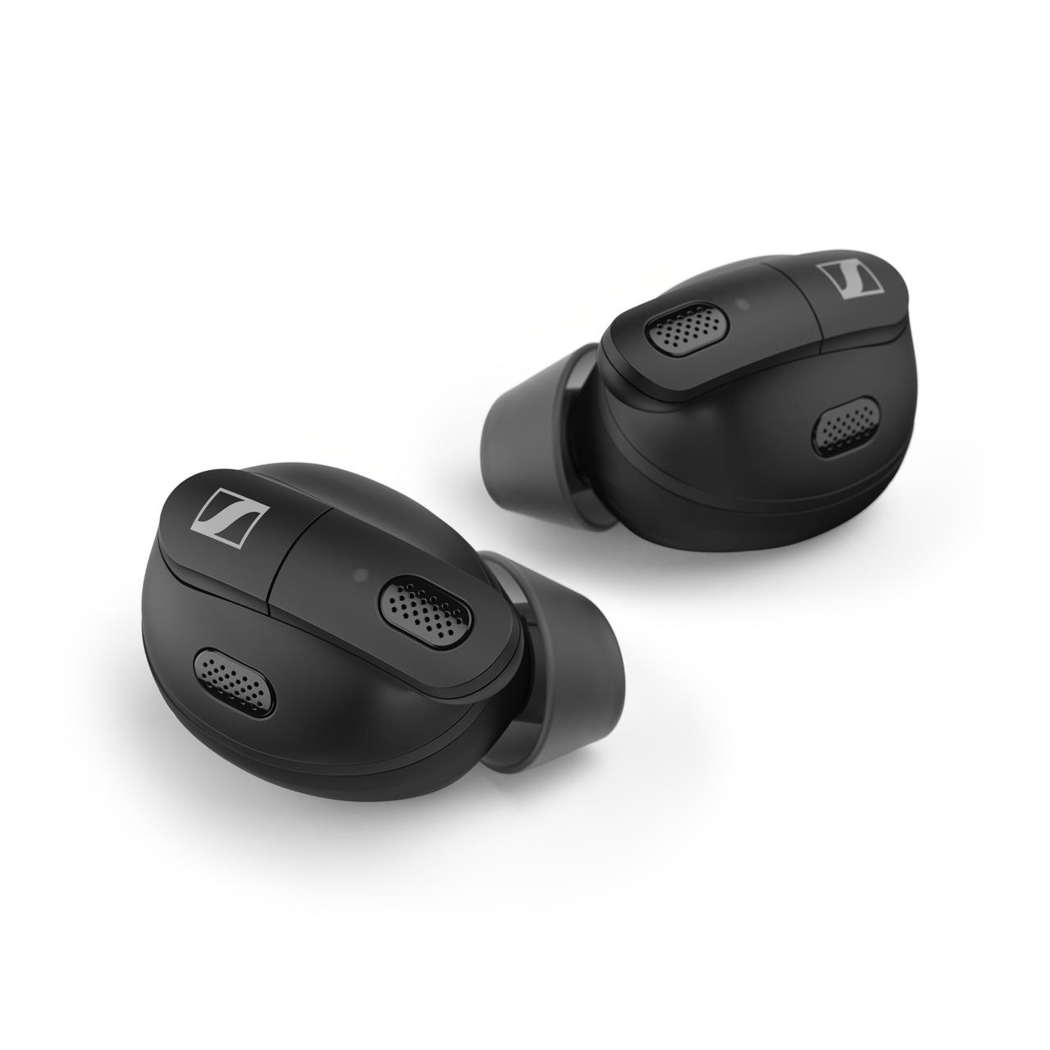
Effortlessly clear conversations in noisy environments
Utilising sophisticated Sonova chip technology, conversations and calls are enhanced thanks to the Sennheiser Automatic Scene Detection feature, which analyses the noise level of a user's environment and matches the speech enhancement level to their surroundings.

Integrated into the compact and modern earbuds, Automatic Scene Detection ensures the clearest speech in challenging environments, be it in person or on the phone. In concert with Active Noise Cancellation, Conversation Clear Plus works dynamically to block distracting noises and improve the clarity of conversations for every level of background noise.

Conversation Clear Plus lets you choose how much background noise you want to hear. Active Noise Cancellation blocks out distractions, while the Ambient Awareness mode enables more connection with the outside environment when desired.

"Sennheiser Conversation Clear Plus reflects our customers’ dynamic lives, allowing users to follow every conversation with ease, wherever they are,” says Daniel Holenstein, Sennheiser Senior Product Manager. “An independent study showed 95% of users experienced significant speech enhancement in noisy situations when using the product.” *
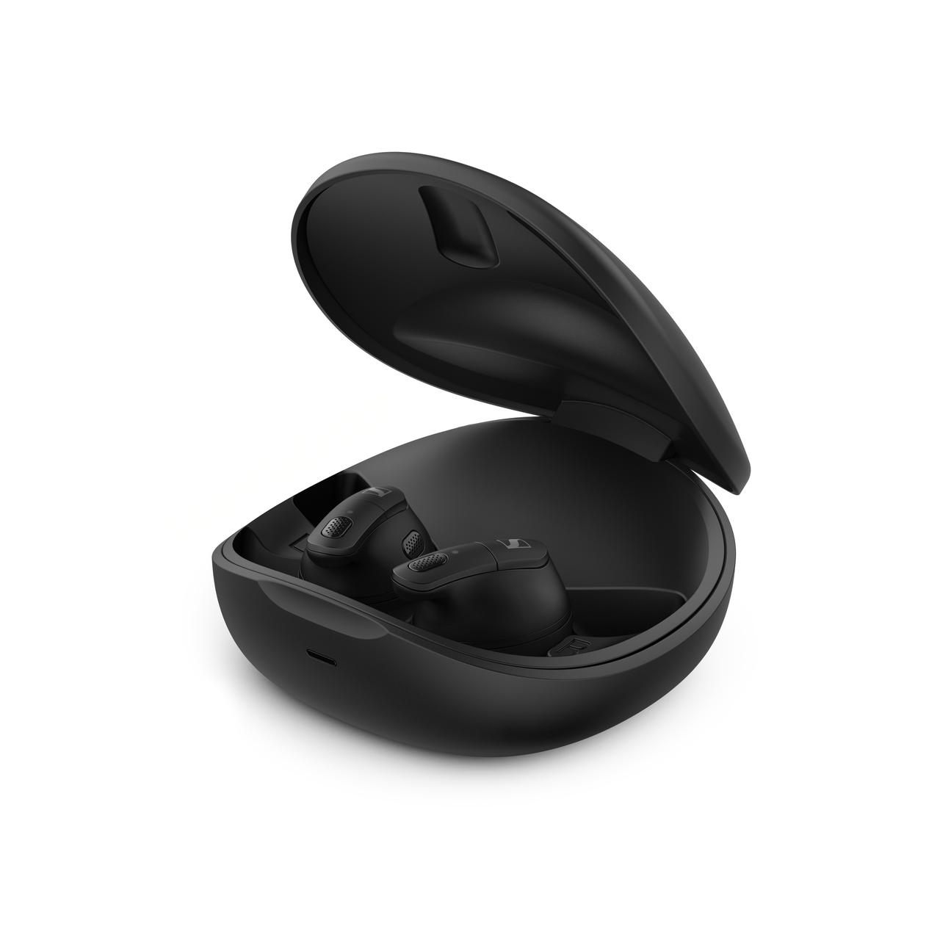

Easy set-up and operation
With step-by-step guidance in the companion app, getting started with Conversation Clear Plus is easy. In combination with the Conversation Clear Plus app, the earbuds deliver an intuitive, hassle-free user experience for tailoring listening preferences.

Dedicated settings for three different listening scenarios make personalising the audio experience effortless. The ‘Relax’ listening scenario lets sound enthusiasts customise the amount of background noise they want to block, while the ‘Communication’ and ‘Streaming’ scenarios automatically adjust settings for the best performance and clarity during conversations and while streaming content, respectively.

Connecting is a breeze with integrated true wireless technology, making pairing with any Bluetooth-enabled device quick and hassle-free. Offering excellent comfort with its ergonomic design, the Conversation Clear Plus earbuds feature an outstanding nine-hour battery life so that they are charged and ready for whenever they are needed. The charging case makes recharging user-friendly on the go, offering another 27 hours of usage time.

Conversation Clear Plus complements the new Sennheiser hearing solutions product category, with best-in-class products for different situations to come in 2023 and beyond.

Pricing and availability
The Sennheiser Conversation Clear Plus will be available for pre-order on January 5, 2023, and on sale on January 20 with an MSRP of £749.

* Conversation Clear Plus performance study, FORCE Technology, 2022

About the Sennheiser brand
We live and breathe audio. We are driven by the passion to create audio solutions that make a difference. Building the future of audio and bringing remarkable sound experiences to our customers – this is what the Sennheiser brand has represented for more than 75 years. While professional audio solutions such as microphones, meeting solutions, streaming technologies and monitoring systems are part of the business of Sennheiser electronic GmbH & Co. KG, the business with consumer devices such as headphones, soundbars and speech-enhanced hearables is operated by Sonova Holding AG under the license of Sennheiser.
www.sennheiser.com
www.sennheiser-hearing.com

About Sonova Consumer Hearing
Sonova Consumer Hearing offers premium headphones and hearables – primarily in the true wireless segment – as well as audiophile headphones, enhanced consumer hearing solutions and soundbars under the Sennheiser brand. The business is part of The Sonova Group, a global leader in innovative hearing care solutions with headquarters in Switzerland and 17,000 employees worldwide.

Press contact
Sonova Consumer Hearing GmbH
Paul Hughes
Head of PR and Influencers
Sennheiser Headphones & Soundbars
T +49 (0) 162 2921 861
paul.hughes@sonova.com

Sennheiser UK&I PR agency
sennheiser@harvard.co.uk

